Dynamic modelling and speed control of a Wind turbine generator system

Introduction:
As the demand for renewable energy increases, wind turbines play a major role in power generation worldwide, converting kinetic energy from the atmosphere into electrical energy using rotating mechanical systems. Therefore, it is important that the turbine drivetrain is both reliable and capable of operating efficiently.
For a wind turbine to operate effectively, the angular velocity must be regulated within a safe range to ensure efficient electrical conversion and to avoid excessive mechanical loading. Variations in wind speed and changes in electrical load applied by the generator directly affect turbine angular velocity, making system stability a key priority for long-term operation.
Due to the variable nature of wind conditions and generator loading, disturbances are frequently introduced into the system. These disturbances make the system operate dynamically rather than at a fixed operating point, resulting in fluctuations in the angular velocity of the shaft that can be difficult to predict. If these fluctuations are not appropriately controlled, energy conversion efficiency may be reduced, mechanical components may degrade more rapidly, and unsafe operating conditions may occur due to overspeed.
This project investigates the dynamic behaviour of a simplified wind turbine-generator system through mathematical modelling and simulation, analysing system behaviour both with and without the application of feedback control to demonstrate the importance of control in improving overall system stability.

System description:
The system analysed in this project is a wind turbine-generator drivetrain that is simplified to only include rotational dynamics, excluding unnecessary complexity. Aerodynamic torque produced by the wind acts to drive the shaft, while the generator produces resisting torque as electrical power is generated. Mechanical losses, such as friction and damping, are present in the system and oppose the motion of the shaft. The primary variable of interest is the angular velocity of the shaft, as it directly influences the efficiency of energy conversion and the amount of electrical power that can be generated.

Assumptions:
- The drivetrain is modelled as a single rotating body with lumped rotational inertia
- The shaft is assumed to be rigid with no torsional deformation
- Mechanical losses are modelled as viscous damping, proportional to the angular velocity
- Aerodynamic wind torque is treated as an external disturbance input to the system
- Generator torque is treated as controllable resisting torque applied to the shaft
- Electrical dynamics of the generator and grid interactions are neglected.

Governing Equation – Wind Turbine Drivetrain Dynamics:
The rotational dynamics of the turbine’s drivetrain can be described using Newton’s second law for rotational motion:
$$∑T=J\frac{dω}{dt}$$
Where:
- $∑T$= Total sum of Torque
- J = Moment of Inertia of the system
- $\frac{dω}{dt}$= Angular acceleration
Considering torques acting on the system:
- Aerodynamic torque $T_{aero}$ acts as the driving torque
- Generator torque $T_{gen}$ acts as the opposing torque
- Damping/frictional torque $T_{damp}$ represents mechanical losses
Applying the torque balance:
$As T_{damp}=bω$:
- $b$ = Damping coefficient
- $ω$ = Angular velocity

$$T_{aero}-T_{gen}-bω=J\frac{dω}{dt}$$

Rearranging to express angular acceleration:
$$\frac{dω}{dt}=\frac{T_{aero}-T_{gen}-bω}{J}$$
In this simplified model, $T_{gen}$ is assumed to be proportional to the angular velocity:
$$T_{gen}=Kω$$
- K = Resistance constant

Substituting this into the governing equation:
$$\frac{dω}{dt}=\frac{T_{aero}-Kω-bω}{J}$$
$$\frac{dω}{dt}=\frac{T_{aero}}{J}-\frac{(K+b)}{J}ω$$
Analysis of the governing equation when all variables are held constant:
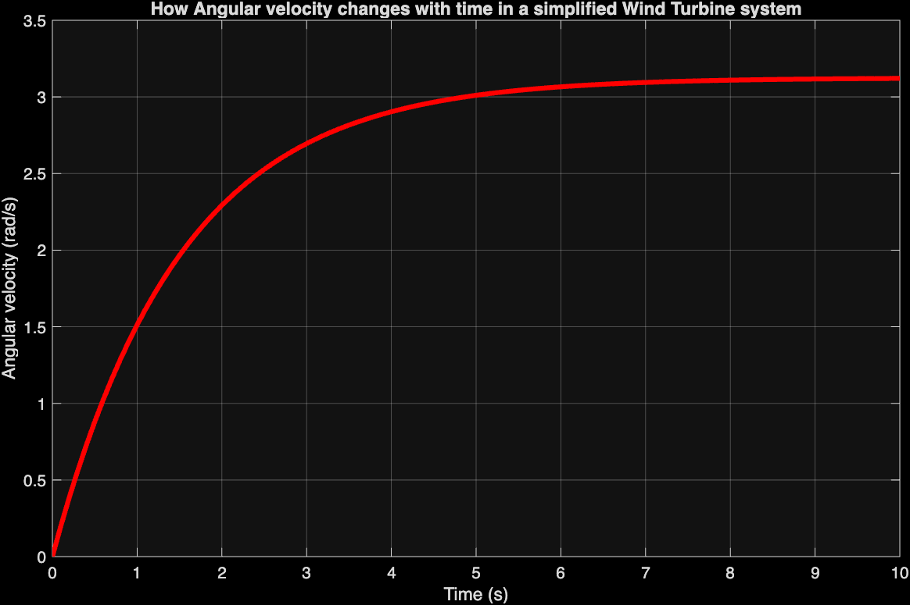
At the beginning of this simulation, the angular velocity increases rapidly due to a larger net driving torque, and initially the damping and generator torques are small, as the angular velocity is small. However, as the angular velocity increases, these opposing torques increase proportionally, reducing the net torque and therefore decreasing the rate of change of angular velocity. Eventually the system reaches a steady state where the two opposing torques are equal to the driving aerodynamic torque, resulting in a constant angular velocity.
Analysis of the governing equation when K is made to be variable:
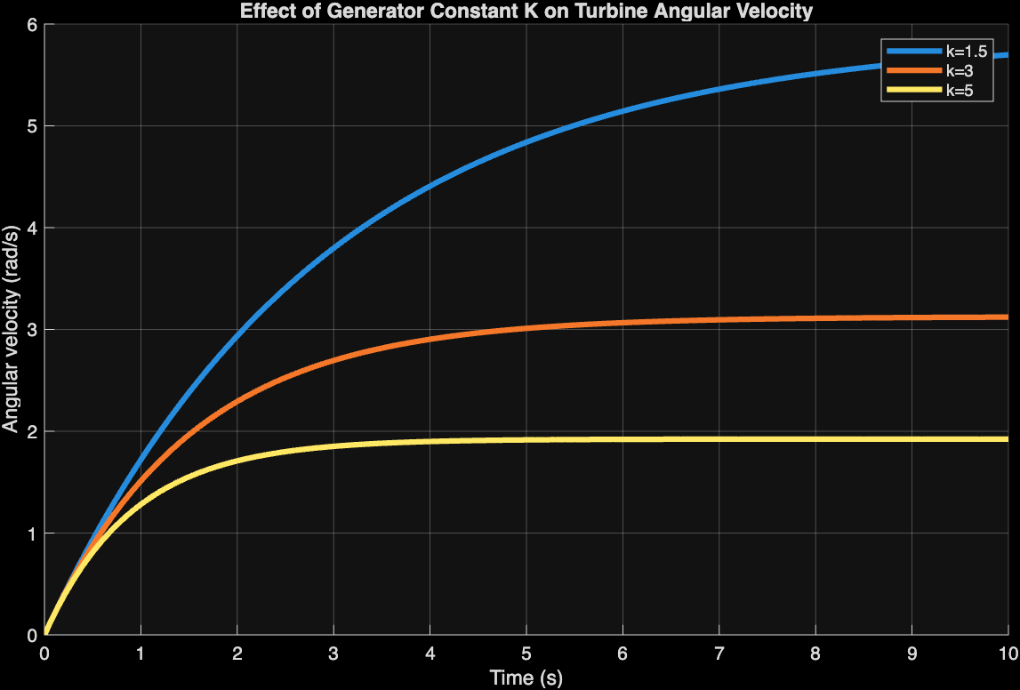
Comparing the different K values used in the simulation, it can be observed that using larger values of K results in a lower steady-state angular velocity. This is because increasing K increases the opposing generator torque for a given angular velocity, decreasing the net driving torque. As a result, the system reaches equilibrium at a lower angular velocity.

Analysis of the governing equation where aerodynamic torque is made to be variable:
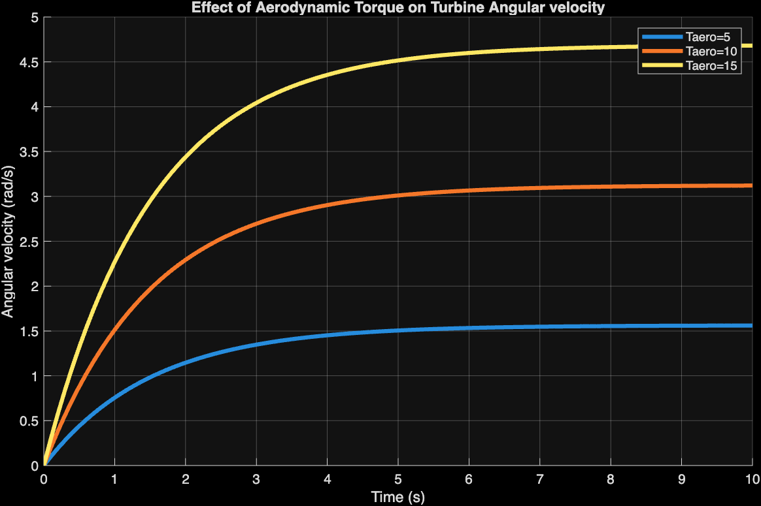
From this simulation, it can be observed that when the aerodynamic torque is increased in this system, the net driving torque is increased. This leads to a greater rate of increase in angular velocity in the system and a higher steady-state angular velocity. As angular velocity increases, the opposing generator and damping torques increase until they balance the aerodynamic torque. As the aerodynamic torque is increased, the system reaches equilibrium at a higher angular velocity.

Angular velocity control using proportional control:
To regulate the angular velocity of the turbine, a proportional control law was introduced to adjust the generator torque by the difference of the angular velocity and a desired reference angular velocity. This is shown as:
$$T_{gen}=K_{p}(ω-ω_{ref})$$
- $K_{p}= proportional$ gain
- $ω_{ref}= reference$ angular velocity
Using this expression, the torque can vary dynamically in response to changes in overall system speed.
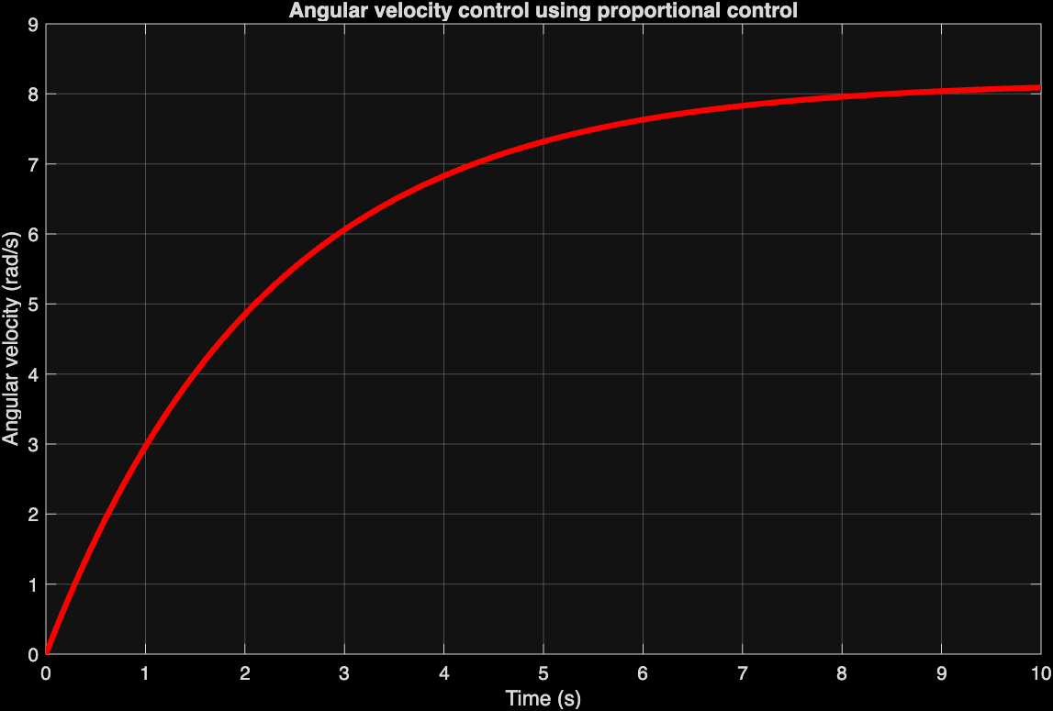
Introducing proportional control into the system allows the generator torque to depend on the difference between the actual angular velocity and a desired reference angular velocity. This enables the system to respond to changes in angular velocity. However, in this simulation the system did not settle at the desired angular velocity of 4 rad/s and instead settled at around 8 rad/s. This is because proportional control by itself is not sufficient to counteract the effects of aerodynamic torque, leaving a gap between the reference angular velocity and the steady-state angular velocity the system settled at.
Conclusion:
This project investigated the dynamic behaviour of a simplified wind turbine generator system through mathematical modelling and simulation. The results showed that the system reaches a steady-state angular velocity due to the balance of aerodynamic, generator and damping torques. Varying system parameters displayed how increasing generator resistance torque reduces the steady-state angular velocity, while increasing aerodynamic torque raises it. Introducing proportional control showed that the system can react dynamically to changes in angular velocity, although there is a steady-state difference between the reference and actual values. Overall, the project highlights the importance of control in regulating turbine operation while maintaining stable performance.
This project is based on fundamental principles of rotational dynamics and basic control theory.

Appendices:
Appendix A: MATLAB Code
The following MATLAB scripts were used to simulate the system behaviour described in this report.
A.1-Base simulation
J=5;
b=0.2;
K=3;
Taero=10;

dt=0.1;
t=0:dt:10;

omega=zeros(size(t));

omega(1)=0;

for i=1:length(t)-1
Tgen=K*omega(i);
Tdamp=b*omega(i);

Tnet=Taero-Tgen-Tdamp;

domega_dt=Tnet/J;

omega(i+1)=omega(i)+domega_dt*dt;
end

plot(t,omega,"r", "LineWidth",3)

xlabel('Time (s)')
ylabel('Angular velocity (rad/s)')
grid on
title('How Angular velocity changes with time in a simplified Wind Turbine system')

A.2-Effect of generator constant K
J=5;
b=0.2;
Taero=10;

K_values=[1.5,3,5];

dt=0.1;
t=0:dt:10;
hold on
for K_index=1:length(K_values)

K=K_values(K_index);

omega=zeros(size(t));

omega(1)=0;

for i=1:length(t)-1
Tgen=K*omega(i);
Tdamp=b*omega(i);

Tnet=Taero-Tgen-Tdamp;

domega_dt=Tnet/J;

omega(i+1)=omega(i)+domega_dt*dt;
end

plot(t,omega, "LineWidth",3)
end
legend('k=1.5','k=3','k=5')
xlabel('Time (s)')
ylabel('Angular velocity (rad/s)')
grid on
title('Effect of Generator Constant K on Turbine Angular Velocity')

A.3-Effect of aerodynamic torque
J=5;
b=0.2;
K=3;

Taero_values=[5,10,15];

dt=0.1;
t=0:dt:10;
hold on
for Taero_index=1:length(Taero_values)

Taero=Taero_values(Taero_index);

omega=zeros(size(t));

omega(1)=0;

for i=1:length(t)-1
Tgen=K*omega(i);
Tdamp=b*omega(i);

Tnet=Taero-Tgen-Tdamp;

domega_dt=Tnet/J;

omega(i+1)=omega(i)+domega_dt*dt;
end

plot(t,omega, "LineWidth",3)
end
legend('Taero=5','Taero=10','Taero=15')
xlabel('Time (s)')
ylabel('Angular velocity (rad/s)')
grid on
title('Effect of Aerodynamic Torque on Turbine Angular velocity')

A.4-Proportional control simulation

J=5;
b=0.2;
Taero=10;

Kp=2;
omega_ref=4;

dt=0.1;
t=0:dt:10;

omega=zeros(size(t));

omega(1)=0;

for i=1:length(t)-1
Tgen=Kp*(omega(i)-omega_ref);
Tdamp=b*omega(i);

Tnet=Taero-Tgen-Tdamp;

domega_dt=Tnet/J;

omega(i+1)=omega(i)+domega_dt*dt;
end

plot(t,omega,"r", "LineWidth",3)

xlabel('Time (s)')
ylabel('Angular velocity (rad/s)')
grid on
title('Angular velocity control using proportional control')

